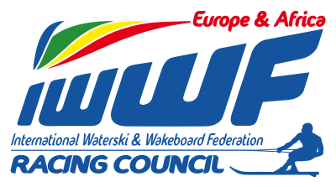 Competitor’s Corner

Info – News Bulletin : 3/2015
M.Avella seeking team/tow in 2015

Dear racing friends

I guess/hope most teams are getting geared for the 2015 racing season

Please be advised that South African/Spanish skier Marc Avella has been training this winter (see below link to one of the recent trainings) in SA and is currently looking out for a team/tow during the upcoming season.

Teams interested in towing Marc during 2015 pls contact

Manel Avella : +27 (0) 71 2398300 or mavella@netactive.co.za

- http://youtu.be/fjqwbEWZYYE training in SA

Looking forward to seeing you all at the first European race in Ybbs on May 24th !!

Yours in Water-ski Racing
Chris RYDL
Athlete’s Rep E&A

